Neighborhood Map Project
Assignment: This assignment is to give you some familiarity with the elements of a map. On a plain sheet of paper, draw a map of your neighborhood. Include all four elements of a map – title, key/legend, indicator of direction, and indicator of scale. You will create a smaller rough draft copy of your neighborhood first. After you have completed your rough draft, your SS teacher will give you a blank sheet of poster paper to make your final map. When you turn in your map, you must have your rough draft attached to the final map. Below is the rubric for this assignment as well as an explanation of requirements:

Title 5—The title must be in bold letters so that it can be read from a distance, outlining it in marker or colored pencil will do this.

Compass Rose 5—Make sure to indicate which way is north, south, east, and west. You can include intermediate directions if you would like.
Key 15—The legend must explain EVERYTHING you have included on your map and be in the colors you used on the map. For example, a blue tree on your map, must be blue in your map key.
Color 15—The map must be completed in color. Points will be taken off if your coloring is not neat. There should not be major areas of white space on your map.
Street Names 10 —At least 2 streets/roads in your neighborhood should be labeled with the correct name on the map.
Neatness 15— This entire map must be drawn by you, so take your time when drawing. If your map is messy, points will be deducted.
Distinguished House 10—Your house must be distinguished (which house is yours?) Drawn an arrow or simply think of a way to make your house stand out.
Scale 5—You don’t need to be precisely accurate with your scale, just give it the best estimate you can. I suggest using feet or yards when using the scale for your neighborhood.
Rough Draft 10—Does not need to be in color BUT must be completed before you can get your poster paper. Must be attached to your final map.
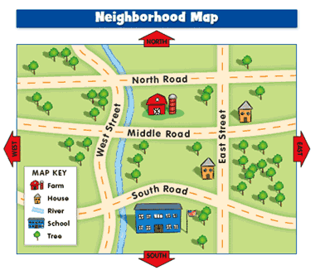
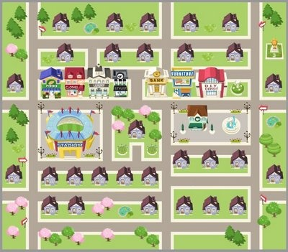
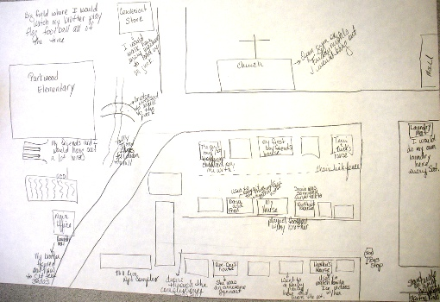
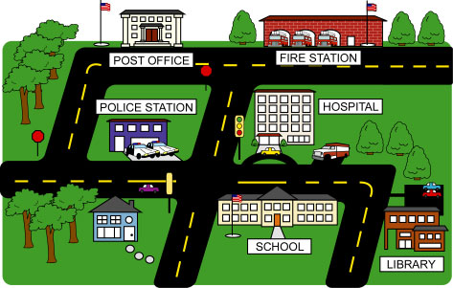
Turned in on time 10—Your neighborhood map project is due AUGUST 17.

